**INVESTIGATION OF WASTE HEAT ENERGY HARVESTING FROM COCONUT SHELL CHARCOAL PRODUCTION**

AN UNDERGRADUATE THESIS

Presented to

the Faculty of

the Department of Electrical Engineering and Technology

College of Engineering and Technology

MSU – Iligan Institute of Technology

Iligan City

In Partial Fulfillment

of the Requirements for the Degree

BACHELOR OF SCIENCE IN ELECTRICAL ENGINEERING

**EMMANUEL B. CAYMO JR.**

**SETH JOVAN M. PACTURANAN**

**THEO ORLANDO D. REDOBLE**

**DR. CARL JOHN O. SALAAN**

Adviser

May 2020

**APPROVAL SHEET**

The undergraduate thesis attached hereto, entitled “**INVESTIGATION OF WASTE HEAT ENERGY HARVESTING FROM COCONUT SHELL CHARCOAL PRODUCTION**”, prepared and submitted by Emmanuel Burlat Caymo Jr., Seth Jovan Manlegro Pacturanan, and Theo Orlando Dela Rama Redoble, in partial fulfillment for the degree of **BACHELOR OF SCIENCE IN ELECTRICAL ENGINEERING**, is hereby recommended for approval.

**PROF. RENNIE E. MICULOB PROF. ANACITA P. TAHUD**

Member Member

_______________ _______________

Date Date

**DR. CARL JOHN O. SALAAN**

Adviser

_______________

Date

**PROF. ROGELIO F. BERSANO**

Co-Adviser

_______________

Date

This undergraduate thesis is approved in partial fulfillment of the requirements for the degree of BACHELOR OF SCIENCE IN ELECTRICAL ENGINEERING.

**PROF. ALLENN C. LOWATON DR. NOEL R. ESTOPEREZ**

Chairperson, EET Department Dean, COET

_______________ _______________

Date Date



s

**ABSTRACT**

As the world is experiencing the harsh effects of global warming from centuries of use of nonrenewable energy, renewable energy, as an alternative, is getting pushed further for use to help hamper the hasty development of global warming. In this study, TEGs could potentially be used for basic needs such as lighting especially for rural areas.

The study mainly revolves around harvesting the excess heat produced by the process of making charcoal with coconut shells. The study includes the use of Thermoelectric Generators, or TEGs in short, for the sake of producing electricity. For investigation purposes, a monitoring system through MATLAB was developed.

A furnace with multiple heat-insulating layers was developed in order to act as the charcoal pit that is traditionally used in the production of coconut shell carcoal. The furnace then had 8 square holes in which the TEGs were fitted into. During the experimentation, the output from the TEGs were then stored into a battery bank. The results of the experiment showed that the setup was able to gather enough voltage to be stored into a battery which would then be used for basic lighting.

In conclusion, the proposed setup using thermoelectric generators would suffice in powering homes in rural areas for basic lighting. Adding more thermoelectric generators in series would potentially improve outputs.

***This work is solely dedicated to***

***Our family***

***Our friends***

***Our loved ones***

***And our computers***

**ACKNOWLEDGEMENT**

*“Friendship is like peeing on yourself: everyone can see it, but only you get the warm feeling that it brings.”*

*-* Robert Bloch

The journey to get here was fairly relaxing. We did not lose any sleep, nor did we cry any tears. We did not bother reading any books, nor did we practice solving problems. If you’re still reading, yes, it is what you think. We are lying. The road we took to get here was extremely bumpy and not relaxing at all for we did lose a lot of sleep, cry a lot of tears, read numerous books, and finally, spent countless hours solving the same problems over and over. Despite all of this, we did not cower in the face of adversity. We fought till the bitter end. We persevered.

First of all, we would like to thank the people who brought us here in the first place: our parents. From the beginning, you have guided us to become the people that we are today; you have supported us emotionally by loving us wholeheartedly; and finally, your financial support was just as important. In all seriousness, we cannot overstate how grateful we are to you. This also goes for our brothers, sisters, and relatives, thank you. You all have made this journey much more fun.

To our advisers Dr. Salaan and Prof. Bersano, thank you. We are extremely fortunate and eternally grateful to have had you as our advisers. The knowledge that you passed onto us was key for us to be able to get here and will be used for our future endeavors. This would have not been possible without you, *merci beaucoup!* To all of our teachers, we will never forget you. Every single one of you has given us something that made us a step closer to being a complete person. Finally we would like to thank MSU-IIT for being our home for the past 5 years.

To our friends, we cannot thank you enough. You have been consistently our light in dark, desperate times; you have cheered us on, telling us never to give up while helping us along the way; and most importantly we learned from each other. Words cannot describe how grateful we are for your endless camaraderie.

***Thank you!***

TABLE OF CONTENTS

**TITLE PAGE……………………………………………………………………..i**

**APPROVAL SHEET…………………………………………………………….ii**

**ABSTRACT…...…………………………………………………………………iii**

**DEDICATION...…………………………………………………………………iv**

**ACKNOWLEDGEMENTS.……………………………………………………..v**

**TABLE OF CONTENTS.....……………………………………………………vii**

**LIST OF TABLES………………….…………………………………………...ix**

**LIST OF FIGURES…..……...…………………………………………………..x**

CHAPTER 1 1

INTRODUCTION 1

1.1 Background of the Study 1

1.2 Problem Statement 2

1.3 Objectives of the Study 3

1.4 Significance of the Study 4

1.5 Scope and Limitations of the Study 4

1.6 Definition of Terms 5

CHAPTER 2 7

REVIEW OF RELATED LITERATURE 7

2.1 Electricity in Rural Areas 7

2.2 Waste Heat Energy 8

2.3 Thermoelectric Generator 8

2.3.1 Thermal Insulation 9

2.3.2 Cooling 11

2.4 Energy Storage System 13

CHAPTER 3 15

METHODOLOGY 15

3.1 Making of scaled model of Charcoal Pit 16

3.2 Integration of TEG to the setup 18

3.2.1 Cooling system of TEGs 19

3.3 Development of an Energy Storage System 20

3.4 Implementation of a monitoring system 21

3.4.1 Microcontroller setup 21

3.4.2 Software development 22

CHAPTER 4 24

RESULTS AND DISCUSSIONS 24

4.1 Development of the Charcoal pit 24

4.1.1 Development of the Charcoal pit base 24

4.1.2 Development of the Charcoal pit interior 25

4.1.3 Development of TEG units 27

4.2 Development of the Energy Storage System and Microcontroller Setup 29

4.3 Development of the Monitoring System 30

4.4 Solidworks Simulatiom 31

4.5 Simulink Simulation 35

4.6 Efficacy evaluation of the water cooling system 40

4.6.1 Setup 40

4.6.2 Testing 42

CHAPTER 5 46

CONCLUSION 46

***BIBLIOGRAPHY***

1. **Thermoelectric Generator Module Specifications………………….52**
2. **Datasheet of Furnace Components…………………………………..53**

# LIST OF TABLES

**Table Page**

1 Hot and Cold side results from the flow simulation 34

# LIST OF FIGURES

**Figure Page**

1 Output power with insulation and without insulation 10

2 Schematic of an evaporative cooling system for TEG 11

3 Proposed system block diagram 14

4 Flowchart representation of the major tasks 15

5 Step 1 representation of making the scaled model 16

6 Step 2 representation of making the scaled model 17

7 Step 3 representation of making the scaled model 18

8 Representation of the cooling system with the scaled model 19

9 Proposed energy storage system of the setup 20

10 Proposed microcontroller setup 22

11 Proposed graphical user interface of the monitoring system 23

12 Development the actual Hardieflex base of the Charcoal pit 25

13 Soaking of Isolite fire bricks 26

14 Completed Isolite brick interior 26

15 Metal lid with ceramic wool 27

16 Completed TEG unit 28

17 Complete Energy Storage and Microcontroller Setup setup 29

18 Monitoring System Setup 30

20 Complete SolidWorks representation of the setup 32

21 Material set at 150°C 33

22 Hot and Cold side graphical result 34

23 Side-view temperature of the pit during flow simulation 35

24 Top-view temperature of the pit during flow simulation 35

# LIST OF FIGURES

**Figure Page**

25 Test with 20°C temperature difference 36

26 Test with 40°C temperature difference 37

27 Test with 60°C temperature difference 38

28 Graphical output without MPPT and Boost 39

29 Graphical output with MPPT and Boost 40

30 Testing setup 41

31 Testing setup 42

32 Testing setup with monitoring system 43

33 Testing without water 44

34 Testing with water 45

35 Voltage graph without water 46

36 Voltage graph with water 46

37 TEG Model SP1848-27145 specifications 53

38 HardieFlex Sheet properties 54

39 Isolite Fire Brick LBK-20 properties 55

# 

# INTRODUCTION

## Background of the Study

Due to the modernization of the world, an abundance of waste heat has emerged. Whenever engines run, fire combusts, or any work done by anything, it produces heat, that’s a law of thermodynamics. Commonly, the heat that is produced is discarded to the atmosphere. This discarded heat can be treated as waste heat energy. About 70% of all the energy made by the people is discarded as waste heat (Jones, 2018).

Creating coconut shell charcoal requires a process called pyrolysis. This means coconut shells are burned in a deprived amount of oxygen. The process usually lasts for 6 hours in 75 – 150 degrees Celsius. With this, a large amount of waste heat is produced (Budi et al., 2016). The traditional method in making coconut shell charcoal is by using the “pit method”. This method uses clay to isolate the heat inside the pit (Emrich, 1985). According to (Bensel & Remedio, 2002) the Philippine household consumes around 1.2 million metric of charcoal per year. Three surveys were conducted by the National Statistics Office about charcoal consumption in terms of household energy consumption. Results from the survey done in 1989, 1995, and 2004 showed values of 32.1%, 38.5% and 34.2% respectively.

Energy demand has rapidly been growing the last century. The increase of demand will continue as the rate of expenditure grows as people strive to improve their standards of living (N B Klinghoffer, Themelis, & Castaldi, 2013). Thermoelectric generator, or also known as TEG, is an instrument for converting heat into electricity. This is possible based on the phenomenon called the Seebeck effect (Ahiska & Dişlitaş, 2011). Simply, the TEG produces higher voltage if the temperature gradient is also high. There are multiple advantages in using TEGs. These include being extremely reliable, environmentally friendly, small, not position-dependent, etc. A downside in using TEG is their low conversion efficiency (~5%). Due to this fact, TEGs are rarely used in power generation. The uses of TEG which includes Thermoelectricity (Thermoelectric power generation) converts the low-grade thermal energy, such as waste-heat energy, into electrical power (Ismail & Ahmed, 2010)

## Problem Statement

Heat energy which is not utilized in the energy production process and is therefore dissipated to the environment is called waste heat (Skomedal, 2016). Globally, the need for energy is rapidly increasing. Predictions state by 2040, an increase of nearly 30 percent is to be expected. Waste heat converted into energy saves nonrenewable resources (fossil fuel) from producing energy (Jones, 2018). The researchers will investigate the utilization waste heat energy using TEGs from the process of making coconut shell charcoal.

## Objectives of the Study

This study aims to develop a scaled model of a traditional method in making coconut shell charcoal in an energy harvesting system by using TEG and to develop a monitoring system developed in MATLAB©. The study also aims to investigate the power output of the model developed. Specifically, the study intends to:

1. Create a scaled model of a pit for making coconut shell charcoal with a proper insulation system;
2. Integrate the TEG into the setup and develop a cooling system;
3. Develop battery energy storage for the system;
4. Develop a monitoring system with a graphic user interface (GUI) in MATLAB.

## Significance of the Study

This study opens an opportunity for TEG use for power generation in small isolated communities, where a lack of electricity is present. This also presents an opportunity to make use of waste heat energy (Trip, Burca, & Morgos, 2017). In energy harvesting, when using a TEG as a power generator, it uses waste energy source where the temperature is not too high. Small temperature gradient only generates small electric power (Ishiyama & Yamada, 2012). The researchers believe that this study presents an opportunity for farmers to make use of the waste heat energy in places with lack of electricity.

## Scope and Limitations of the Study

This study focuses on the application of TEG on utilizing the waste heat energy produced in making coconut shell charcoal and will be using a scaled model of the traditional method in making coconut shell charcoal. The study aims to investigate the potential energy that can be harvested from the said set-up. Furthermore, the study aims to develop a means of cooling without the use of electricity. Lastly, the researchers will develop a battery energy storage for the system.

## Definition of Terms

**Thermoelectric Generator (TEG)** - A thermoelectric generator, also called a Seebeck generator, is a solid state device that converts heat flux directly into electrical energy through a phenomenon called the Seebeck effect

**Seebeck Effect -** a phenomenon in which a temperature difference between two dissimilar electrical conductors or semiconductors produces a voltage difference between the two substances.

**Temperature Gradient** - the rate of change of temperature with displacement in a given direction

**Waste Heat -** heat that is produced by a machine, or other process that uses energy, as a byproduct of doing work

**Thermal Insulation** – is the reduction of heat transfer between objects in thermal contact or in range of radiative influence. Thermal insulation can be achieved with specially engineered methods or processes, as well as with suitable object shapes and materials.

**Charcoal** – a porous black solid, consisting of an amorphous form of carbon, obtained as a residue when wood, bone, or other organic matter is heated in the absence of air.

**MATLAB** – is a multi-paradigm numerical computing environment and proprietary programming language developed by MathWorks. MATLAB allows matrix manipulations, plotting of functions and data, implementation of algorithms, creation of user interfaces, and interfacing with programs written in other languages

**GUI** – also known as graphical user interface, is a form of user interface that allows users to interact with electronic devices through graphical icons and audio indicator such as primary notation, instead of text-based user interfaces, typed command labels or text navigation.

**Arduino** - an open-source hardware and software company, project and user community that designs and manufactures single-board microcontrollers and microcontroller kits for building digital devices.

# 

# REVIEW OF RELATED LITERATURE

## Electricity in Rural Areas

Due to the rise of the human population and changes in locations for human settlement, numerous sites have improved. This led to an increase of need for electrification. Most of these areas are in remote and unviable off-grid locations. As of July in 2016, electrification coverage for households in the Philippines were at 89.6%. This meant 2.36 million households had an absence of electricity while other areas were granted four to six hours of electricity per day (DOE, 2016). According to Philippine Energy Secretary Alfonso Cusi in 2017, the electrification of households, specifically in rural areas, is a problem for the Philippine government (“2.36 million Philippine households without electricity: study - Xinhua | English.news.cn,” 2017).

As stated on the Energy Access Outlook 2017, 1.1 billion people, roughly 14% of the world’s population, were deprived of electricity. Around 84% of that estimate are people residing in rural areas. Additionally, roughly 95% of people with no access of electricity are mainly from developing Asian and sub-Saharan African countries (International Energy Agency, 2017).

## Waste Heat Energy

In 2009, a report by Enova talking about the waste heat in Norway concluded that for the Norwegian industry, 25% of waste heat could be used for waste heat recovery (Skomedal, 2013). Though for the report, only few technologies such as the steam-turbine, the organic rankine cycle (also known as ORC) and the Stirling-engine were mentioned in the discussion. In one recent example, a new energy recovery system was built at Elkem Salten3. This recovery system is capable of saving 30% of the consumption of electricity (Sollesnes & Helgerud, 2009).

A Waste Heat Recovery Power Generation (WHRPG) plant was installed for The Philippine Sinter Corporation’s (PSC) sintering plant, located in Cagayan de Oro City. The WHRPG plant, installed by JFE Engineering Corporation, makes use of the sintering plant’s cooler’s waste gas. The heat originating from the waste gas is collected by the plant. The WHRPG plant is capable generation of generating 18.5 MW (JFE Engineering Corporation, 2019).

## Thermoelectric Generator

For the ever-progressive automotive industry, development of an engine’s efficiency is constantly improving. An example of improvement is the use of heat energy in car radiators. The thermoelectric generator (TEG) is used to utilize the heat energy. Through this, production of electrical energy is possible and minimizes the engine’s workload. The set-up used, composed of 4 pieces of TEGs connected in series was placed on top of the Lomabardini diesel engine. With this the experiment, 2.05 volts was produced (Awria, Albana, & Hakim, 2018).

In another case, the TEG was used in utilizing the waste heat of an incinerator. The set-up composed of 24 modules of thermoelectric generator connected in series was designed to be capable of producing 20 watts of power. The system was developed with a cooling technique and a temperature control examine the characteristics. Optimal power output could be established at a certain condition (Fauzan et al., 2019).

### Thermal Insulation

A study on enhancing efficiency of thermoelectric generators (TEGs) tested on how to improve the output of a setup Involving thermoelectric generators. The study found that applying improved heat insulation resulted in an increase of 5% for the output power as shown in the figure below (Tang, Deng, Su, Shuai, & Xie, 2015).

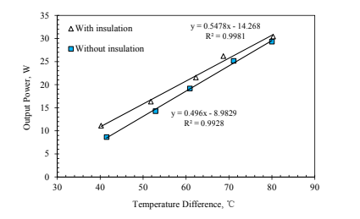

**Figure 2.3.1.1.** Output power with insulation and without insulation

A kind of brick that can both be used as insulation and for handling high temperatures are Insulating Fire Bricks. They’re designed to line fireplaces, fireboxes, kilns, and furnaces. Also known as “refractory bricks”, these bricks can withstand up to 1760 °C with minimal heat conduction in order to provide better energy efficiency (Refractory Engineers Inc., 2017).

Polyethylene foam is a closed-cell material that is also lightweight, durable, and resilient. Fragile goods are often packaged by Polyethylene foam due to its insulation properties with excellent vibration dampening. Additionally, P.E foam also provides high resistance to chemicals and moisture. Polyethylene foam is easy to process and fabricate. It has high load bearing characteristics that help manufacturers reduce packaging costs as they can use thinner and smaller amounts of foam yet still protect their products (UFP Technologies Inc., 2020).

### Cooling

The TEG’s hot side is usually in contact with a heat source. This heat source can be a waste heat pipe or concentrated solar radiation. Meanwhile, the TEG’s cold side is usually retained to low temperatures by using cooling methods. The different types of methods of cooling TEGs and their classifications are shown in the figure below (Kumar et al., 2019).

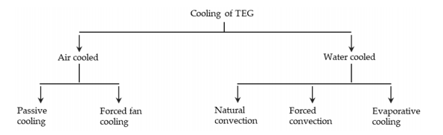

**Figure 2.3.2.1.** Schematic of an evaporative cooling system for TEG

#### Passive Cooling

Passive cooling, which involves dispersing heat from the cold side to the air, is accomplished by natural convection. A study conducted (Dell, Thomas Petralia, Pokharel, & Unnthorsson, 2019) showed how a thermoelectric generator composed of six Laird thermoelectric modules, achieved an output of 6.9 W of steady state power with a 130 °C temperature difference. Ambient air cooling was selected as the setup’s cooling system.

Another study, also using a passive cooling system, showed that reducing the length of the heat sink while increasing the frontal area of the heat sink displayed that the TEG output power density improved by 88.70% (Wang, Hung, & Chen, 2012).

#### Water Cooling

For most of the existing thermal systems, including the TEG, water cooling is the most common method for cooling. Due to the abundance of water and its high threshold for heat capacity, water cooling is seen as appealing when choosing a method of cooling (Kumar et al., 2019).

A study involving Stove-powered TEGs (SPTEGs) made use of a water cooling system. Results showed an over 27 W electric power output generated with a temperature difference of 250 °C (Lv, Li, Zheng, Hu, & Li, 2018).

## Energy Storage System

Renewable sources generate energy that are usually first in electrical form. This generated energy can be either stored in mechanical, electrical, or electrochemical storage systems. The Electrochemical Energy Storage System, known as the Battery Energy Storage System (BESS), uses rechargeable batteries for energy storage. The Lead acid batteries, Alkaline (Nickel) batteries, Silver batteries, and Lithium batteries are the four major classifications of today’s rechargeable batteries (Ogunniyi & Pienaar, 2017).

A study (Dalala, Hamdan, Al-Taani, Al-Addous, & Albatayneh, 2019) which implemented battery storage system consisted of a TEG bank, a battery bank, a DC-DC boost converter, and a control circuit. The system is shown in the figure below.

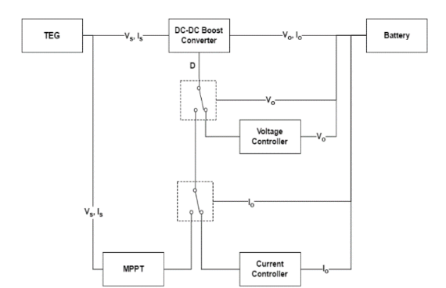

**Figure 2.4.1.** Proposed system block diagram

# 

# METHODOLOGY

This chapter focuses on the steps performed by the researchers to accomplish the task. This chapter is divided into four sections: the first section describes the making of the charcoal pit model, the second section tackles on the integration of the TEGs into the setup, the third section shows the making of the energy storage system of the setup, and lastly, the section shows the development of the monitoring system consisting of the microcontroller and GUI in MATLAB.

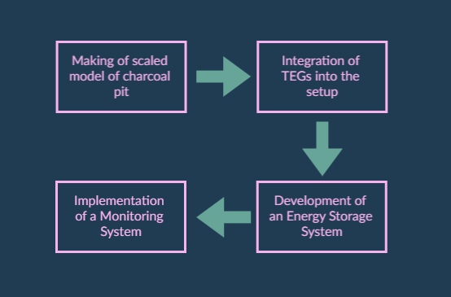

**Figure 3.1** Flowchart representation of the major tasks

## Making of scaled model of Charcoal Pit

The researchers used three main components for the pit. First five Hardieflex panels (0.7m x 0.7m) were put together as the foundation and the base of the pit. Isolite fire bricks were selected as the main and interior form thermal insulation. Additionally, a square metal sheet with ceramic wool on the sides were placed on top of the pit as cover. In addition, Polyethylene foam was chosen to be placed as a final outer layer.

**Step 1:** The Hardieflex panels were put together using metal brackets to form square pit. Also, two holes from each side (45mm x 45mm) were carved for the integration of the TEG to the setup.

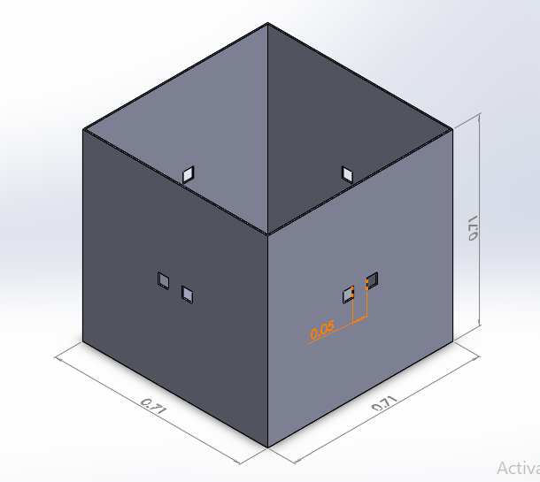

**Figure 3.1.1**. Step 1 representation of making the scaled model

**Step 2:** The Isolite fire bricks were arranged together reaching the opening of the pit to form the interior. Similarly, holes were made on the bricks similar to the holes on the Hardieflex panels.

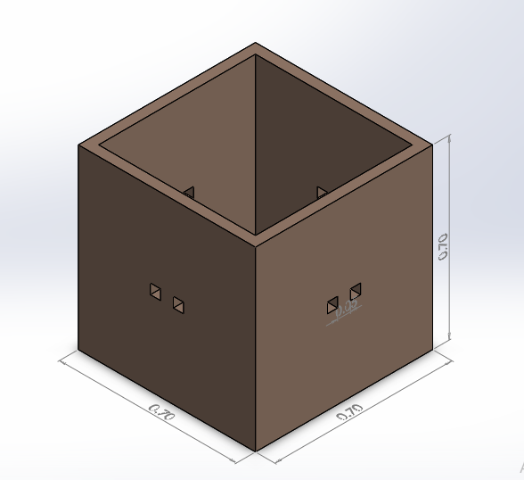

**Figure 3.1.2.** Step 2 representation of making the scaled model

**Step 3:** Lastly, the Polyethylene foam was used to cover the outermost layer of the Hardieflex panels to further improve the thermal insulation of the setup. Again, holes were made in line with the previous holes on the Hardieflex panels.

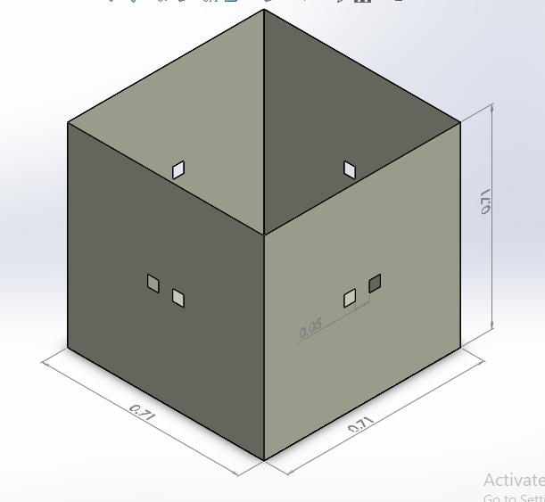

**Figure 3.1.3.** Step 3 representation of making the scaled model

## Integration of TEG to the setup

The researchers used eight modules of TEGs (Model here) connected in series. As mentioned in the steps before, the TEGs were inserted into the carved holes of the Hardieflex panels. High temperature resistant silicone rubber adhesive was used to lock TEGs in place. The wires connecting TEGs to one another were wrapped in high temperature resistance tape to prevent damages due to the heat.

### Cooling system of TEGs

Heat sinks were attached on both the hot and cold sides of the TEGs; this helped in distributing the heat evenly. Thermal adhesive was used to provide better conduction of heat to the TEGs. For the cold side of the TEGs, the researchers planned used a water cooling system for cooling purposes. The cooling system that was developed involved placing tubes around the pit using cold water to go through the fins of the heat sinks. The researchers believe that due to the general location of the traditional way of making coconut shell charcoal, being in the rural areas, the cold water is expected and is sufficient for cooling.

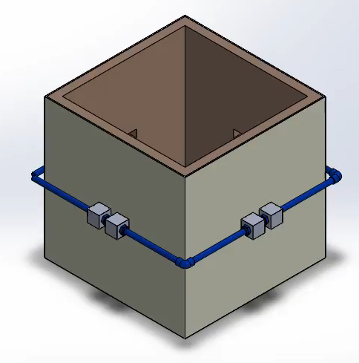

**Figure 3.1.4.** Representation of the cooling system with the scaled model

## Development of an Energy Storage System

The output of the series-connected TEGs were connected to a DC-DC converter. This is due to the nature of the setup where the voltage output of the TEGs is inconsistent. The inconsistency stems from the uncontrollable temperature difference of the TEGs. After the DC-DC Converter, a battery charger was connected to charge the final component of the system which is the battery. In between the battery charger and battery, a voltage sensor was connected in parallel while a current sensor was connected in series.

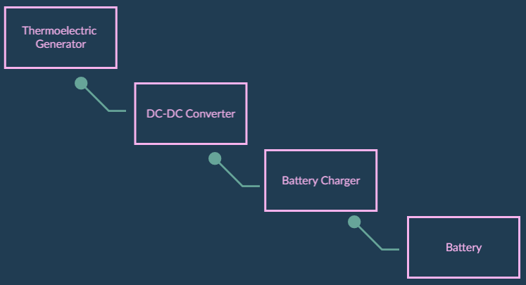

**Figure 3.3.1.** Proposed energy storage system of the setup

## Implementation of a monitoring system

The researchers were made a monitoring system to observe the outputs of the system. The expected outputs, with the help of the voltage, current and temperature sensors, are the temperature of the TEG’s and the output power of the system.

### Microcontroller setup

The researchers, using an Arduino uno as a microcontroller, used the aforementioned sensors to collect data from the system developed. One temperature sensor, to be placed on top of the pit, was used to acquire data to represent the hot side temperature of the TEGs. On the other hand, four temperature sensors were attached to each side of the pit for the cold side of the TEGs. The voltage and current sensors were connected to the output power of the battery charger of the energy storage system. All of these sensors were connected to the Arduino for data acquisition. Shown in Figure 3.4.1.1 is the researchers’ overview of the microcontroller setup.

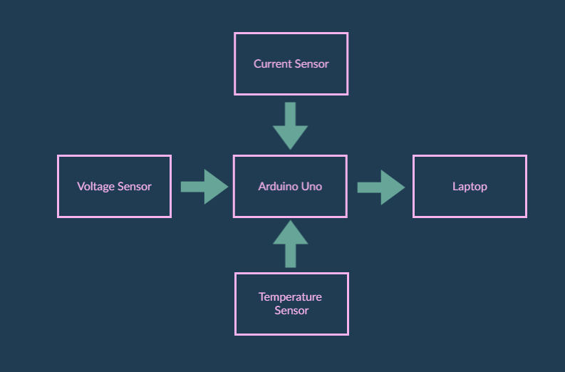

**Figure 3.4.1.1.** Proposed microcontroller setup

### Software development

The researchers developed a graphical user interface in MATLAB to present the data acquired from the microcontroller. The GUI consists of a graph with four separate outputs for each of the sides of the pit for the temperature difference of the TEGs hot and cold side. The total output power of the system was graphed separately. All of the graphs were presented with respect to time. The data acquired was also saved in a file for documentation purposes. Shown in Figure 3.4.2.1, is the graphical user interface to be developed by the researchers

Title

Temperature Difference Graph

Power Graph

Tabled Data Values

**Figure 3.4.2.1.** Proposed graphical user interface of the monitoring system

# 

# RESULTS AND DISCUSSIONS

In this chapter, the results from the plans from the previous were discussed along with discussions about multiple simulations which include the SolidWorks flow simulations and the Simulink simulations.

## Development of the Charcoal pit

The charcoal pit, being the biggest part of the study, was given the most time and effort onto making. The pit comprised of three major parts being the base, the interior, and the exterior. The base was chosen to be Hardieflex, the interior being Isolite fire bricks, and the exterior being Polyethylene foam.

### Development of the Charcoal pit base

Initially, as planned in the previous chapter, five 0.7m2 Hardieflex panels were cut using a laser cutter in FAB LAB Mindanao. Four of the panels each had two 45mm2 holes cut in the middle of the panels. With the use of metal corner brackets, the panels were put up together serving as the base for the pit.

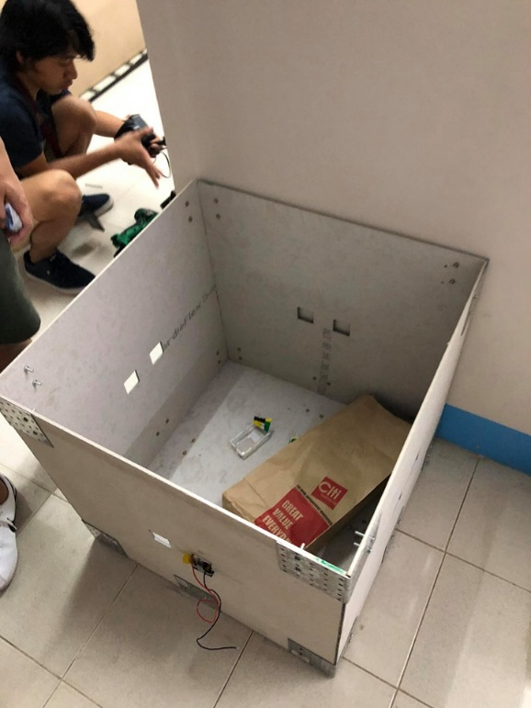

**Figure 4.1.1.1** Development the actual Hardieflex base of the Charcoal pit

### Development of the Charcoal pit interior

Afterwards, the Isolite fire bricks were filed inside the Hardieflex base to serve as the main form of heat insulation. Due to the brick’s porosity, the bricks were each soaked in the water to absorb it and release air. This was done in order for the bricks to not absorb the water from the wet mortar that was used to bind the bricks together. After waiting for the mortar to harden, holes were made in line with the holes in the Hardieflex panels.

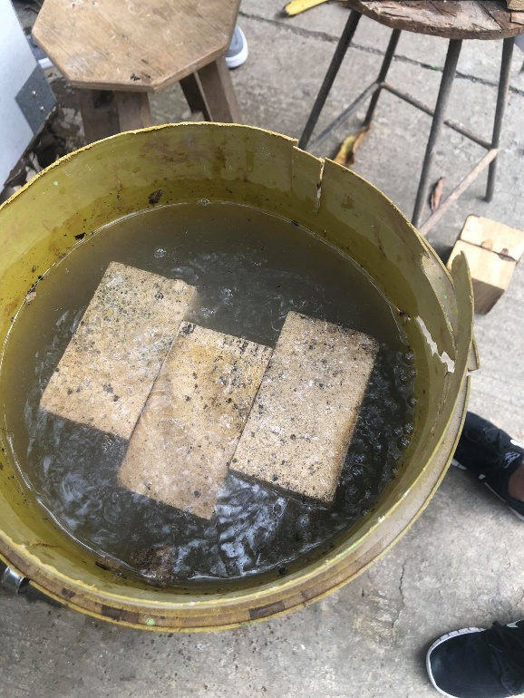

**Figure 4.1.2.1** Soaking of Isolite fire bricks

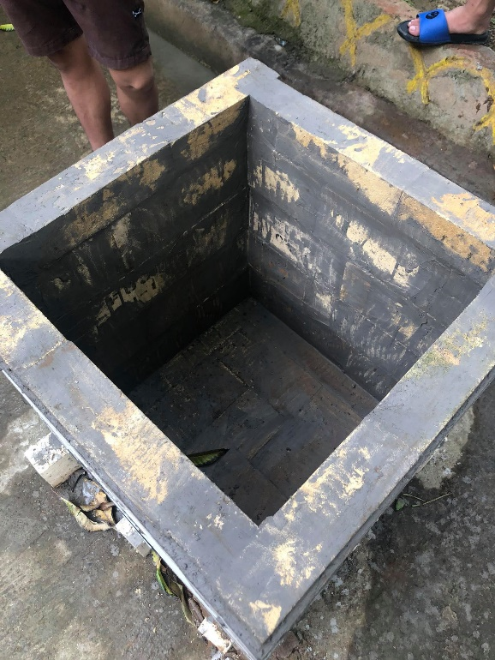

**Figure 4.1.2.2** Completed Isolite brick interior

Lastly, a square metal lid was added along with ceramic wool on the edges of the charcoal pit to improve heat preservation as shown in Figure 4.1.4.

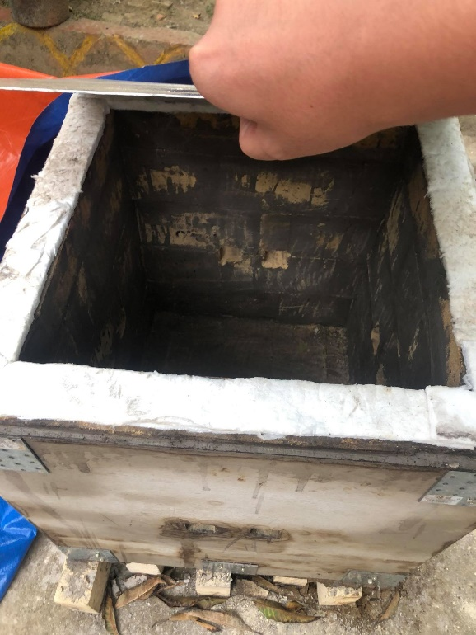

**Figure 4.1.2.3** Metal lid with ceramic wool

### Development of TEG units

Initially, eight tin boxes were fabricated to hold the TEGs in place and was also a part for the water cooling system. All of the TEGs also aluminum had heat sinks in stuck to both the hot side for better heat conduction and the cold side for better heat dissipation. In order to firmly fit the TEG modules onto the fabricated tin boxes, high temperature resistant adhesives were used due to the high temperature nature of charcoal making. As a passage for water to flow through the connected eight TEG units, PVC pipes were used along with washers to firmly fit the pipes into the tin boxes.

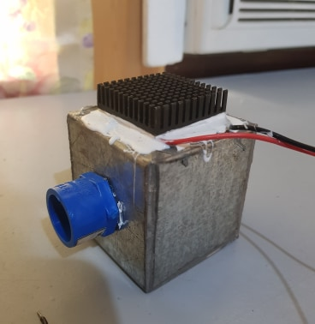

**Figure 4.1.3.1** Completed TEG unit

## Development of the Energy Storage System and Microcontroller Setup

As planned in the previous chapter, the energy storage system and the microcontroller setup was plotted through EasyEDA.

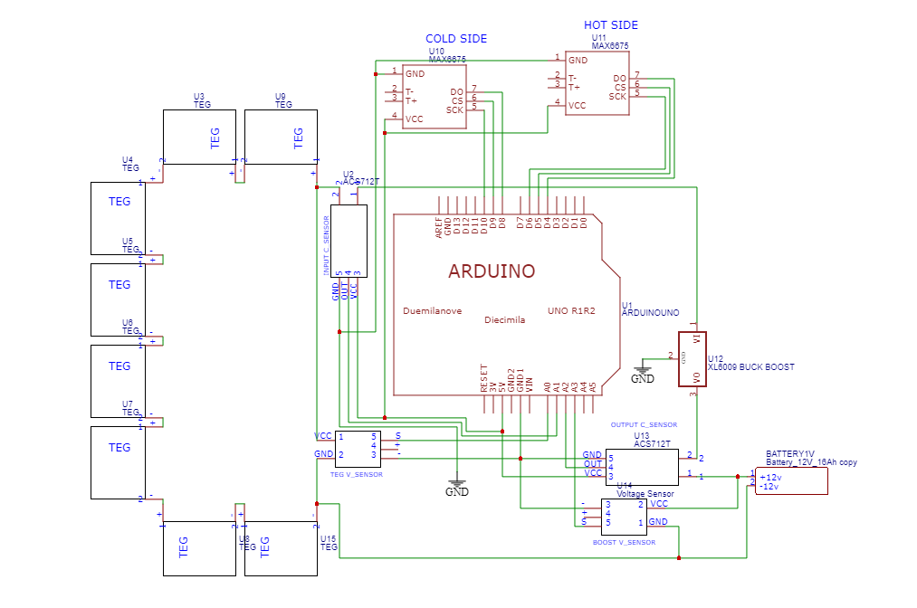

**Figure 4.2.1** Complete Energy Storage and Microcontroller Setup setup

## Development of the Monitoring System

Through MATLAB, a graphical user interface (GUI) was developed as planned in the previous chapter. As shown in Figures 4.3.1 and 4.3.2., the GUI shows all the necessary specifications needed in the study.

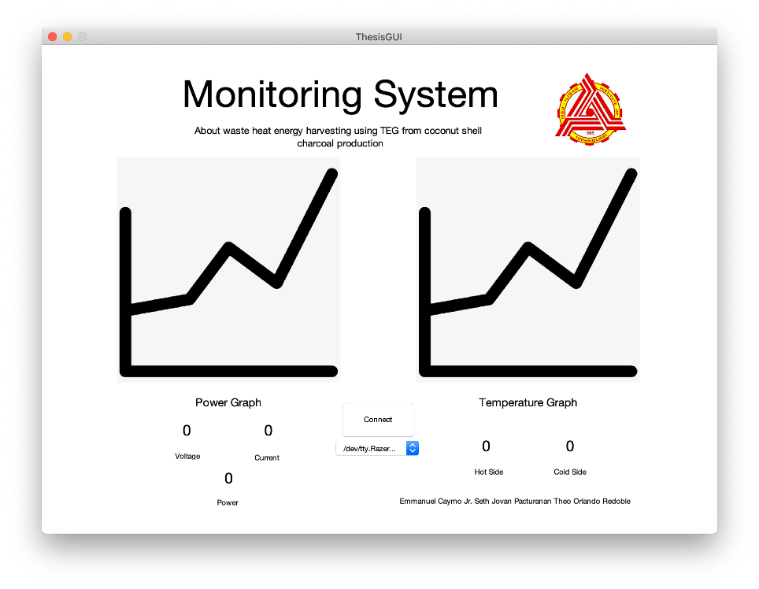

**Figure 4.3.1** Monitoring System setup

## Solidworks Simulatiom

The researchers, using SolidWorks, were able to make a model of the charcoal pit. The charcoal pit model was composed of different materials. The materials included were isolite fire bricks, Hardieflex, aluminum, steel and polyvinyl chloride (PVC) and more. Additionally, these materials each had different respective values for their properties (ρ, C, k, etc.).

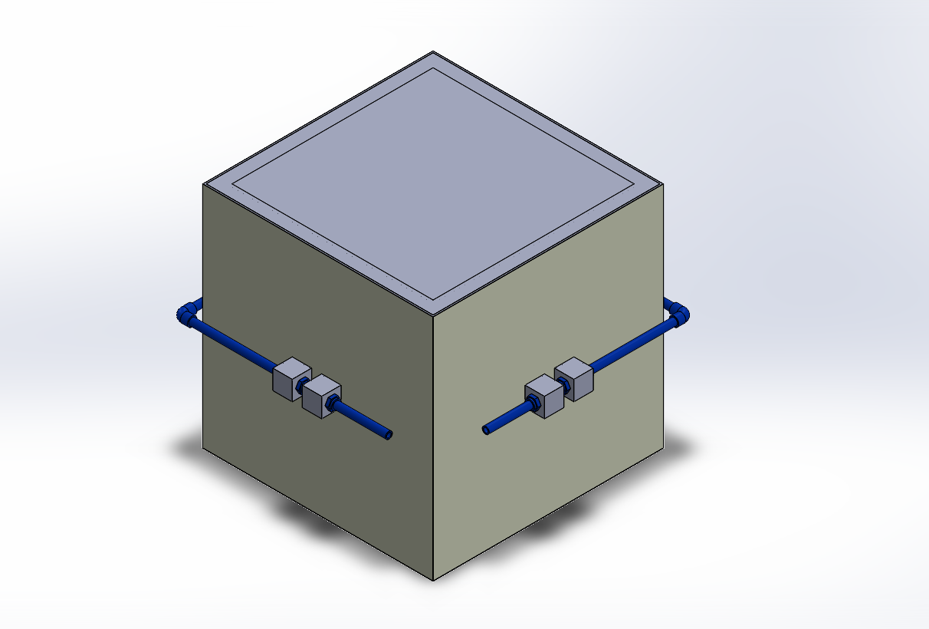

**Figure 4.4.1** Complete SolidWorks representation of the setup

Using the SolidWorks Flow simulation, the researchers were able to get the necessary values specifically the temperatures on the hot side and cold side of the TEGs. The temperature values for both sides are needed for the next simulation to be done in Simulink. For the flow simulation, certain values were assumed. To accurately depict the actual process of charcoal making, the material depicting the burning inside the charcoal pit was assumed to be 150°C given the actual burning process is between 75-150°C.

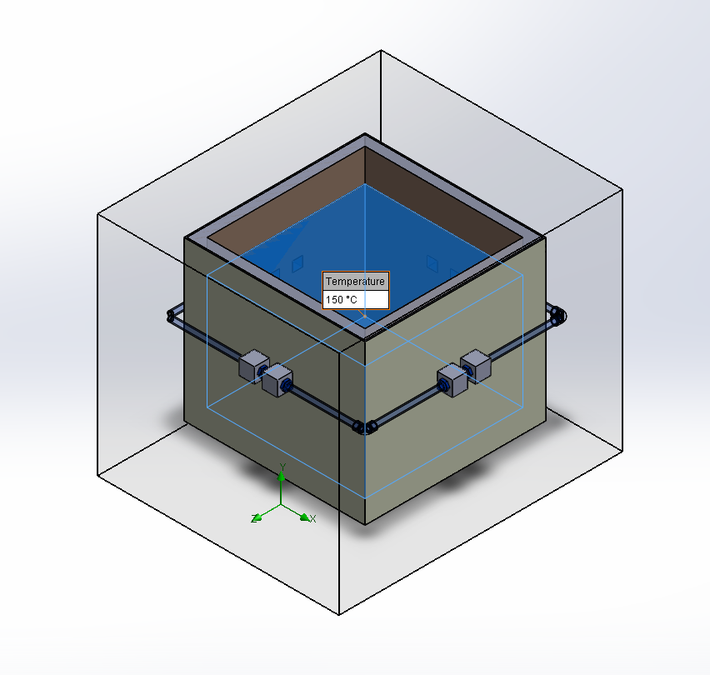

**Figure 4.4.2** Material set at 150°C

Similarly, to emulate actual flowing mountain water, the water temperature running through the tubes was assumed to be 20°C. Under these conditions, after the flow simulation, the values of the hot side and cold side were on average found to be 63.7°C and 38.7°C respectively. The values shown in Table 4.4 shows that the cold side temperature reaches steady-state at approximately 38°C while the hot side remains steady at approximately 63°C.

|  |  |  |  |  |  |
| --- | --- | --- | --- | --- | --- |
| Goal Name | Unit | Value | Averaged Value | Minimum Value | Maximum Value |
| Hot Side | [°C] | 63.36695241 | 63.69008614 | 63.36405801 | 64.14857953 |
| Cold Side | [°C] | 38.67610704 | 38.87602523 | 38.67610704 | 39.13232321 |

**Table 4.4** Hot and Cold side results from the flow simulation

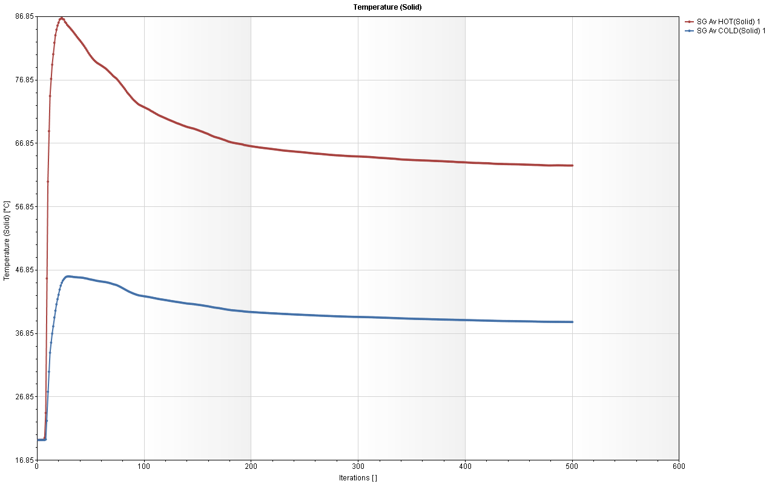

**Figure 4.4.3** Hot and Cold side graphical result

The simulation also showed that the heat inside the pit, as shown in Figure 4.4.4, was not leaking out of the furnace. As shown in the figure, the temperature inside the pit was 150°C. Despite this, the other layers show significant temperature reduction with the outermost layer going down to as low as approximately 20°C. This proved that the materials chosen as the layers for the pit was effective in heat insulation.

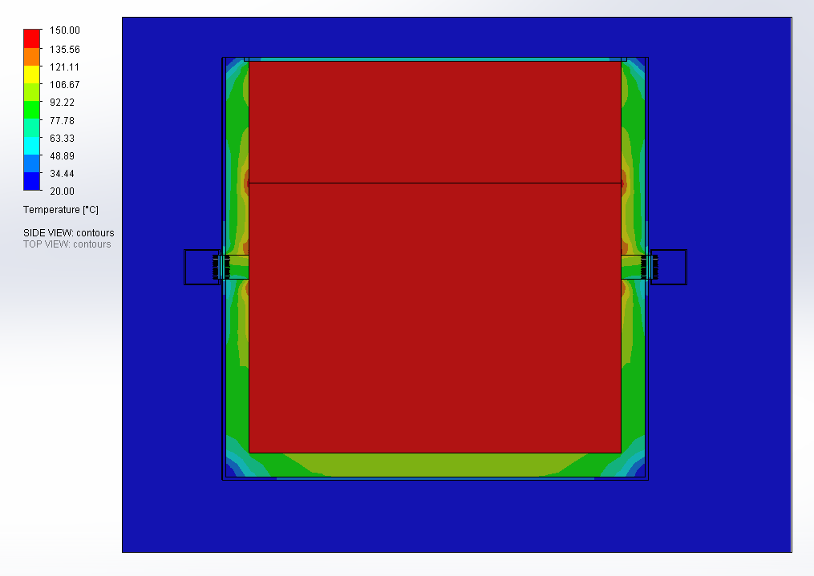

**Figure 4.4.4** Side-view temperature of the pit during flow simulation

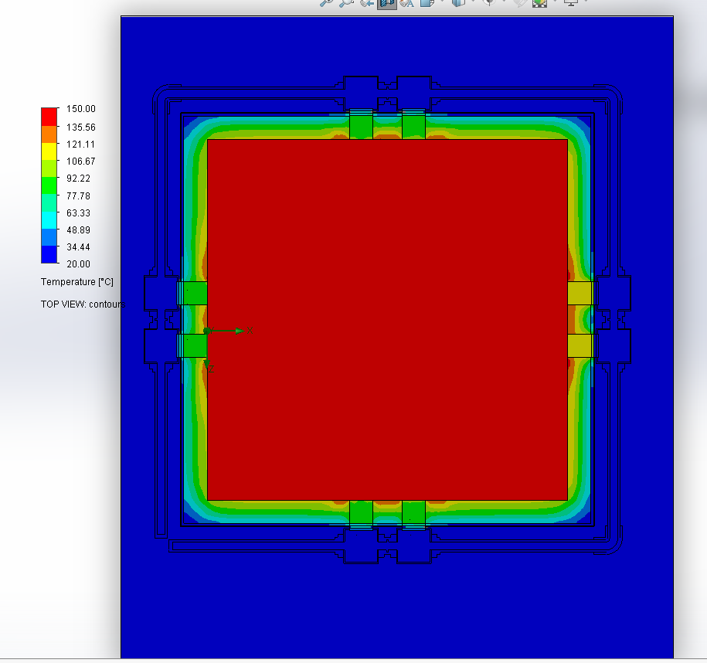

**Figure 4.4.5** Top-view temperature of the pit during flow simulation

## Simulink Simulation

In order to calculate the voltage, current and power generated, Simulink was used by the researchers. Initially, in order to confirm the TEG module to be used in the simulations was accurate, the researchers checked and performed tests to see if the results were in line with the TEG model SP1848-27145 specifications. Firstly, changes to the TEG module’s specifications such as the TEG’s internal resistance, Seebeck coefficient, working temperature, and more were made. As shown in Figure 4.5.1, a test was done with a 20° temperature difference between the hot and cold side of the TEG. The results show an open circuit voltage of 0.889V which is close to the 0.97V open circuit voltage product specification for 20°C temperature difference for the TEG model SP1848-27145.

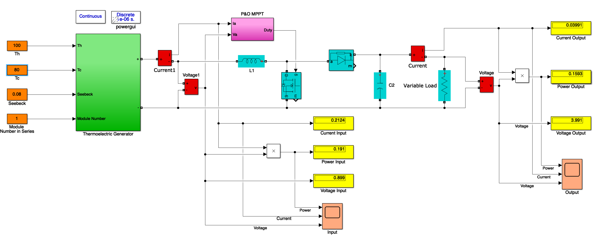

**Figure 4.5.1** Test with 20°C temperature difference

Similarly, in Figure 4.5.2, a test was done with a 40° temperature difference. The results show an open circuit voltage of 1.822V compared to the 1.8V open circuit voltage product specification

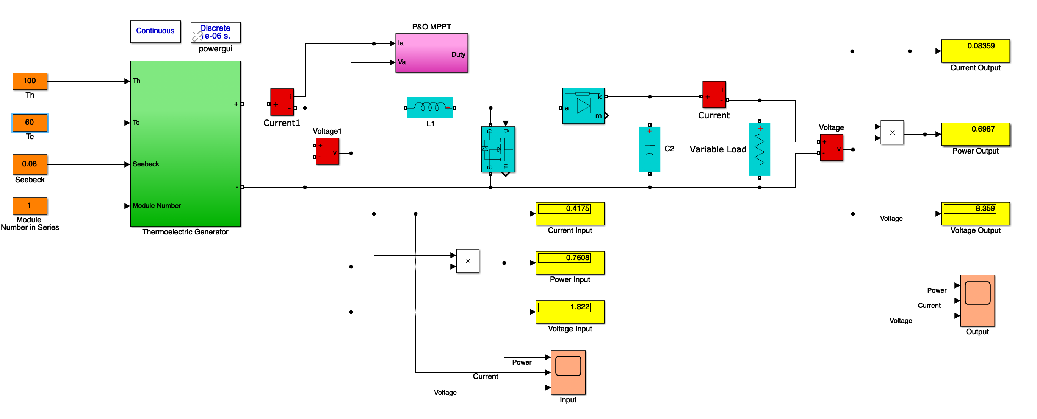

**Figure 4.5.2** Test with 40°C temperature difference

Finally, as shown in Figure 4.5.3, a final 60°C temperature difference test was done. This resulted with an open circuit voltage of 2.733V which is close to the product specification value of 2.4V. In conclusion with all these tests, the researchers deemed the TEG module accurate enough to be a sufficient representation of the actual SP1848-27145 TEG model.

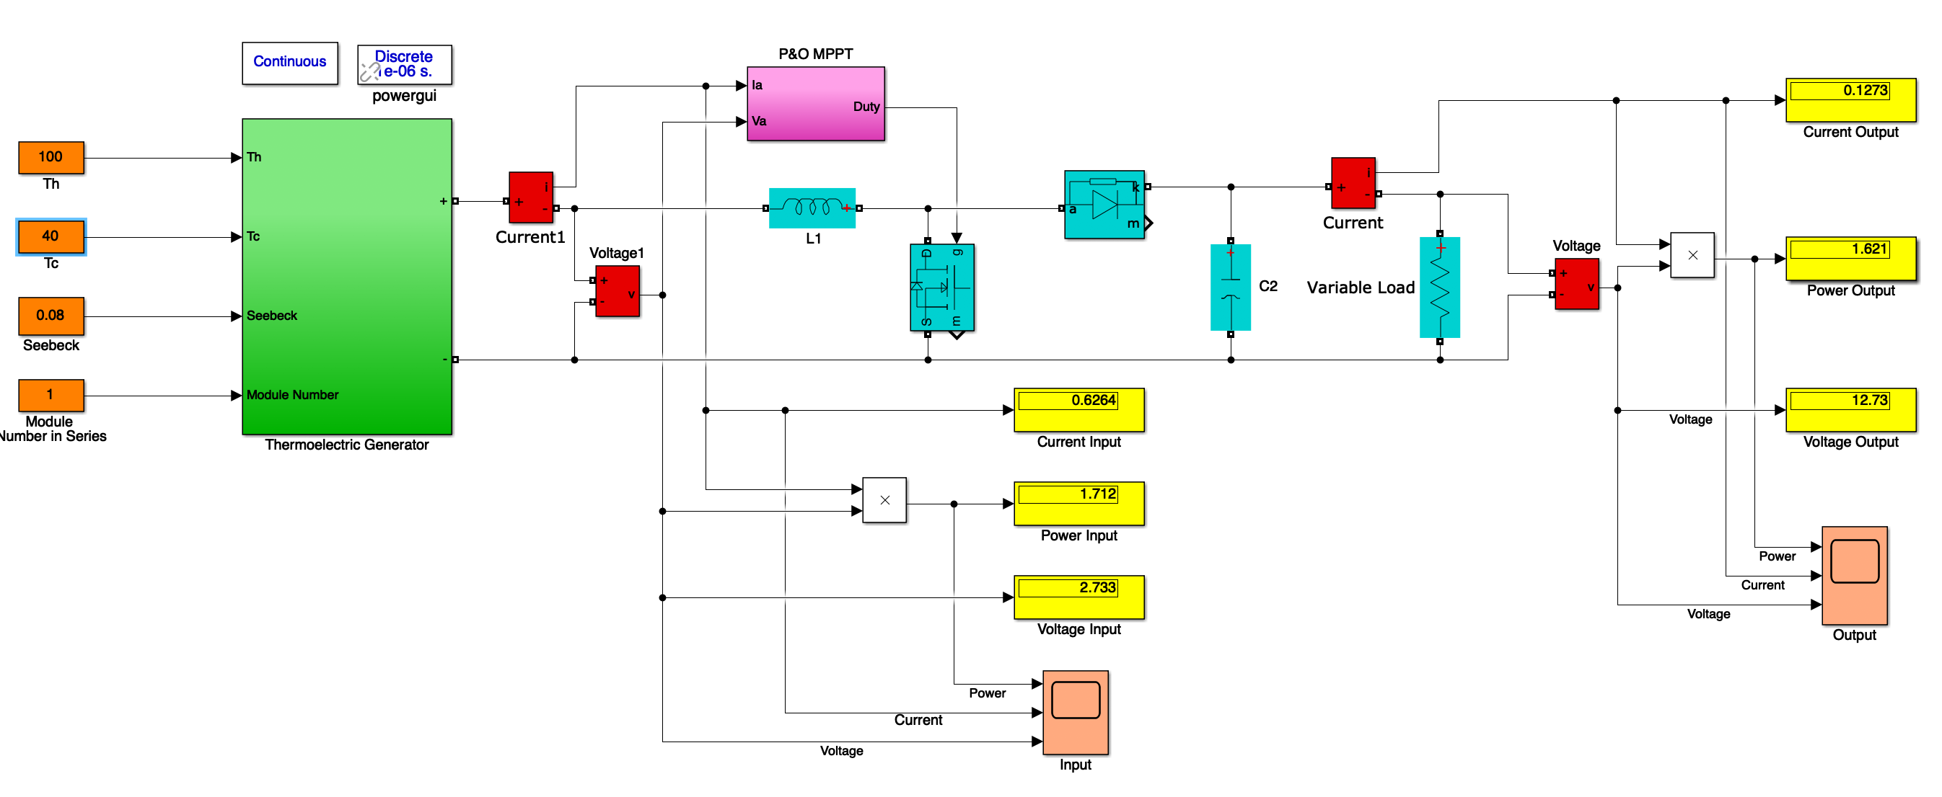

**Figure 4.5.3** Test with 60°C temperature difference

After confirming the accuracy of the specifications of the simulated TEG module, the data gathered from the SolidWorks flow simulation was then used.

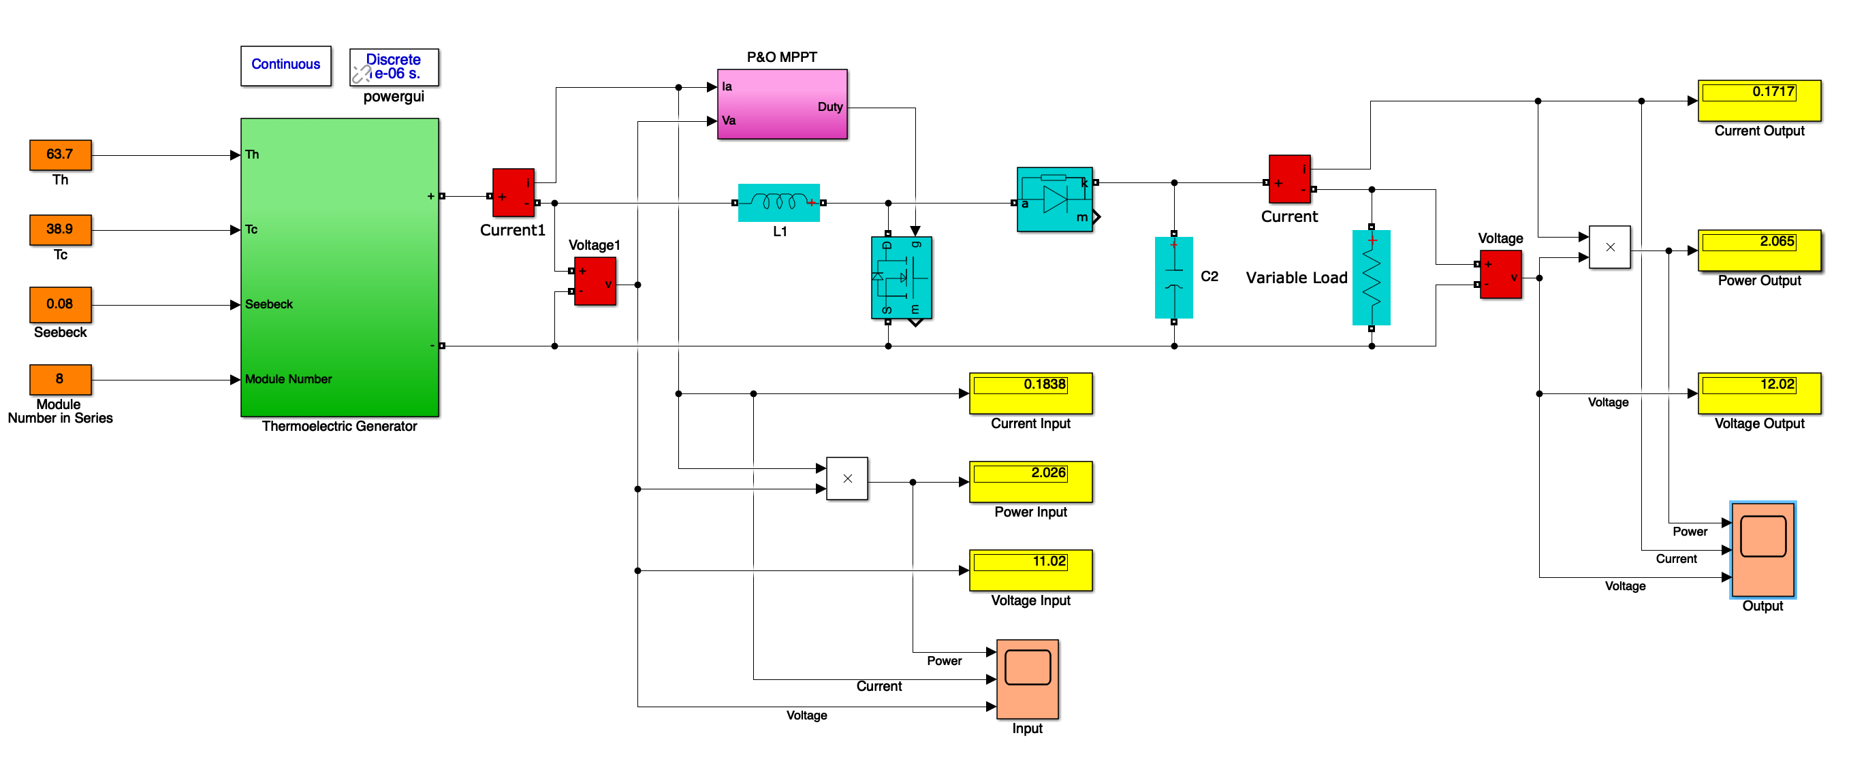

**Figure 4.5.4** Test with the SolidWorks Flow simulation output

As shown in Figure 4.5.5, the output of the system was unstable and fluctuating. In order to fix this, using Maximum power point tracking (MPPT), which finds the most optimal power output along with a boost converter, which further stabilizes the outputs, a better output graph shown in Figure 4.5.6 was achieved. With the help of these DC-DC converters, the output shows that the output power is stabilizing at 2W, the voltage at 12V, and the current at 0.16A.

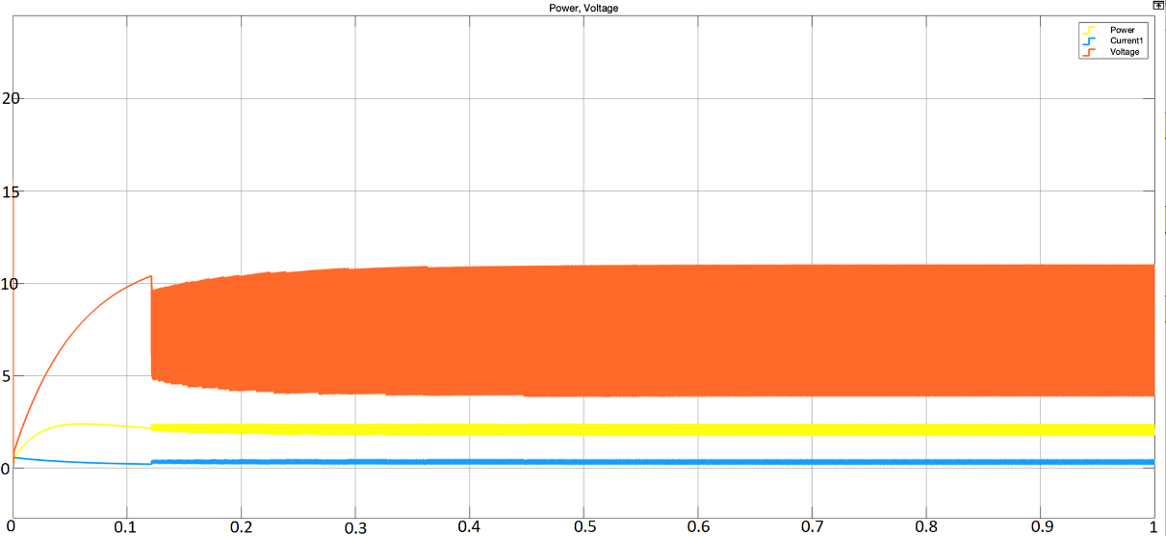

**Figure 4.5.5** Graphical output without MPPT and Boost

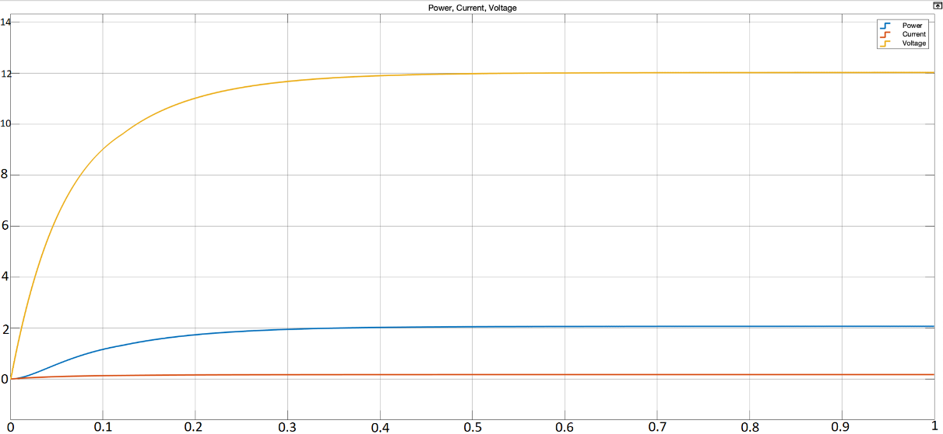

**Figure 4.5.6** Graphical output with MPPT and Boost

## Efficacy evaluation of the water cooling system

This section of the chapter focuses on testing the proposed water cooling system setup. Included in this section is the evaluation the effectiveness of the said setup by performing multiple tests and comparing the data gathered.

### Setup

As was planned in the previous chapter, the researchers tested their water cooling system setup. A smaller scale was used in the testing, using a concrete stove, a single TEG module with PVC pipes, and the necessary things for monitoring (Laptop, arduino, breadboard). As shown in Fig. 4.6.1.1, the TEG module is connected to a hole in the furnace directly exposing the TEG module’s hot side heat sink to the fire. On the opposite of the TEG module is the cold side where flowing water is to consistently pass through.

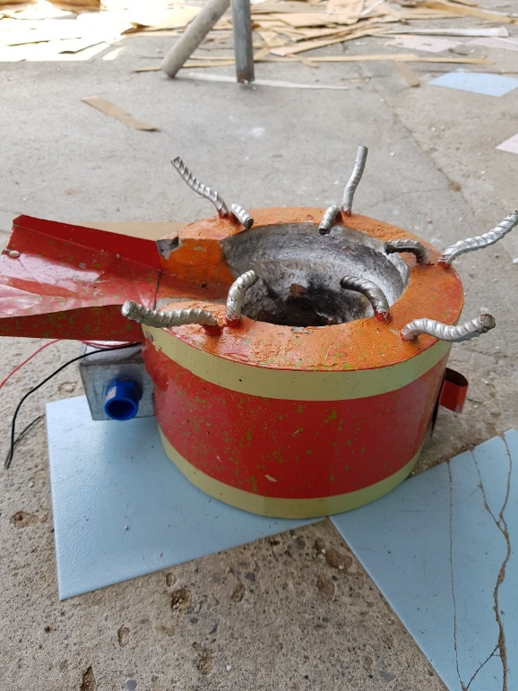

**Figure 4.6.1.1** Testing setup

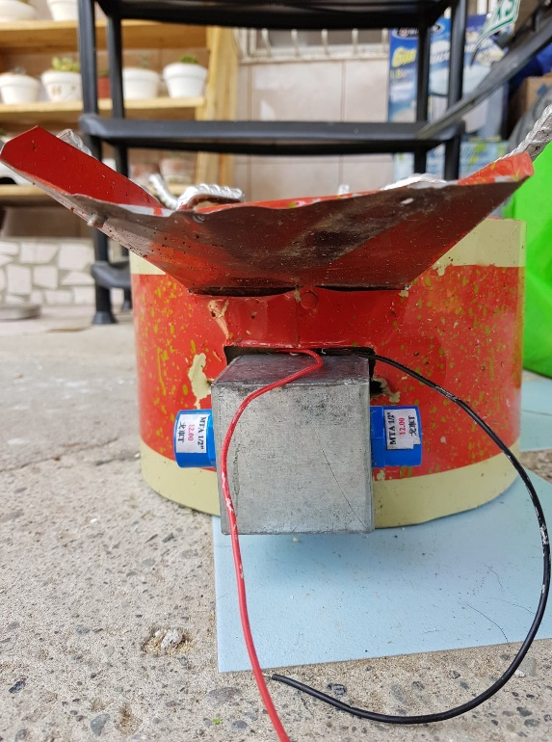

**Figure 4.6.1.2** Testing setup

In addition, Figure 4.6.1.3 shows the monitoring system connected to the stove for the purpose of data gathering.

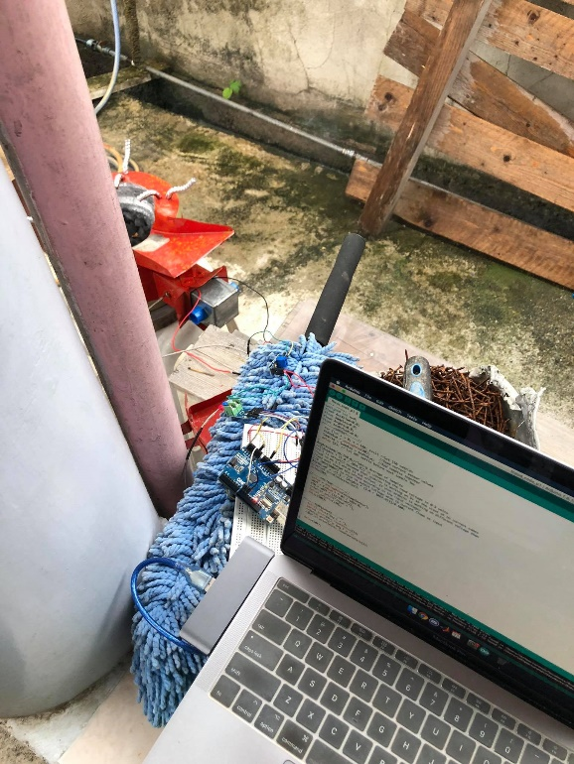

**Figure 4.6.1.3** Testing setup with monitoring system

### Testing

In order to determine the effectiveness of the proposed water cooling system, the researchers performed two parts of the test. The test being comparing the output when burning charcoal without flowing water versus burning charcoal with flowing water on the cold side of the TEG. The researchers initially burned charcoal to create a fire which was used as the source of heat in this experiment. The researchers first tested the system without the use of flowing water as shown in Figure 4.6.2.1.

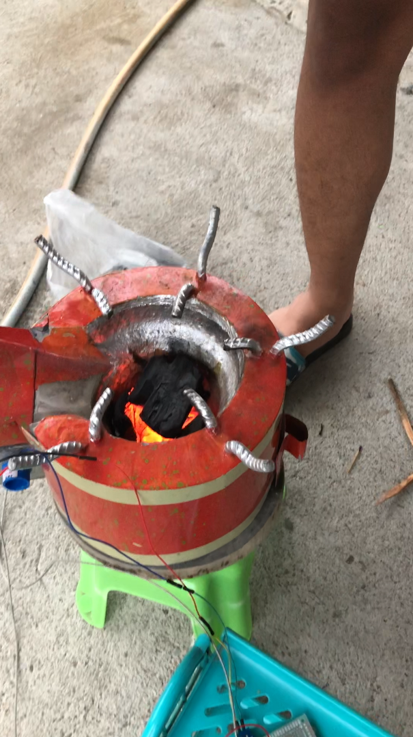

**Figure 4.6.2.1** Testing without water

During the test, a peak voltage of 1.71v was achieved before subsequently going down due to heat conduction which resulted in the temperature of the cold side of the TEG to slowly rise. For the second phase of the testing, as shown in Figure 4.6.2.2, the researchers used cold flowing water to pass through the TEG module’s cold side in order to improve the temperature difference between the hot side and the cold side. With the help of continuously flowing water, the second part of the test garnered a peak of 3.08v. By applying flowing water into the TEG module, this improved the peak voltage by 80.12%.

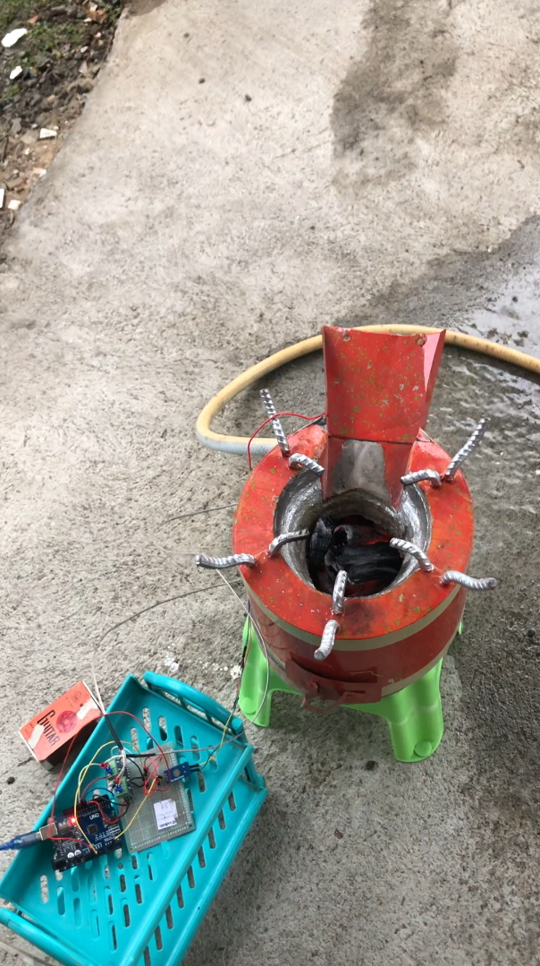

**Figure 4.6.2.2** Testing with water

In the data gathered during the test, Figure 4.6.2.3, a graph showing the voltage produced with respect to time without water cooling shows abrupt voltage drops. In contrast to Figure 4.6.2.4, a graph showing voltage produced with water cooling, shows definite improvement regarding voltage stability along with higher voltage peaks.

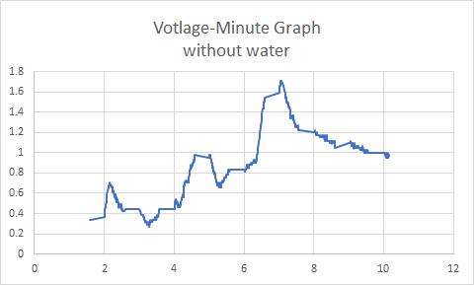

**Figure 4.6.2.3** Voltage graph without water

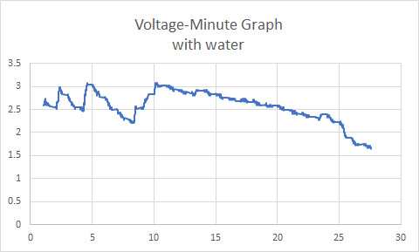

**Figure 4.6.2.4** Voltage graph with water

# 

# CONCLUSION

Based on the tests and results taken from the previous chapter, firstly from the SolidWorks setup, through simulation, the chosen materials (Isolite fire brick, Hardieflex, Polyethylene foam) for heat insulation were found effective given that the temperature of the interior of the pit was at 150°C while the outermost layer was at 20°C. Additionaly, the simulation also found that the hot side temperature of 63.7°C and a cold side temperature of 38.9°C was achieved from the TEG which is a temperature difference of 24.8°C. Using the temperature difference obtained, through Simulink, an output voltage of 11.02v was achieved which was then stepped up to 12v in order to charge the proposed battery storage. This shows that the designed furnace with the TEG modules is capable in charging a battery bank given certain conditions are met (flowing water, cold water, multiple TEGs). A working monitoring system was also developed being able to accurately display the parameters (voltage, current, power) necessary.

**BIBLIOGRAPHY**

2.36 million Philippine households without electricity: study - Xinhua | English.news.cn. (2017). Retrieved November 9, 2019, from http://www.xinhuanet.com/english/2017-09/29/c_136648509.htm?fbclid=IwAR1qNJ__HdRssMa2RBKv4pS5Jy1xBFQbjrXsvpZMwCq1VifbzaOuNGj1eLk

Ahiska, R., & Dişlitaş, S. (2011). Computer controlled test system for measuring the parameters of the real thermoelectric module. *Energy Conversion and Management*, *52*(1), 27–36. https://doi.org/https://doi.org/10.1016/j.enconman.2010.06.023

Awria, A., Albana, M. H., & Hakim, R. (2018). Experimental Study: Design of Thermoelectric Generator (TEG) Fixture for Harvesting an Automobile Electricity. *Proceedings of the 2018 International Conference on Applied Engineering, ICAE 2018*. https://doi.org/10.1109/INCAE.2018.8579151

Bensel, T. G., & Remedio, E. M. (2002). *Woodfuel Consumption and Production in the Philippines: A Desk Study*.

Budi, E., Umiatin, Nasbey, H., Bintoro, R. A., Wulandari, F., & Erlina. (2016). Activated coconut shell charcoal carbon using chemical-physical activation. *AIP Conference Proceedings*, *1712*. https://doi.org/10.1063/1.4941886

Dalala, Z. M., Hamdan, Z. S., Al-Taani, H., Al-Addous, M., & Albatayneh, A. (2019). Battery Charging Application with Thermoelectric Generators as Energy Harvesters. *The Academic Research Community Publication*, *3*(1), 248. https://doi.org/10.21625/archive.v3i1.446

Dell, R., Thomas Petralia, M., Pokharel, A., & Unnthorsson, R. (2019). Thermoelectric Generator Using Passive Cooling. In *Thermoelectrics for Power Generation [Working Title]*. https://doi.org/10.5772/intechopen.85559

DOE. (2016). ESAR. Retrieved November 9, 2019, from https://www.doe.gov.ph/sites/default/files/pdf/transparency/annual_report_esar_2016.pdf?fbclid=IwAR0iTg8OJzjOvbPJUwHER7fT2Wa9hk7X7rAYX2ZobWAa4zWNAfs4rWSjBR0

Emrich, W. (1985). History and Fundamentals of the Charcoal Process. In *Handbook of Charcoal Making* (pp. 1–18). https://doi.org/10.1007/978-94-017-0450-2_1

Fauzan, M. Y., Islam, S., Muyeen, S. M., Wardhana, A. S., Soedibyo, & Ashari, M. (2019). Experimental Modeling of Nano Power Generation using Thermoelectric Generator (TEG) from Incinerator Waste Heat. *Proceeding - 2018 International Seminar on Intelligent Technology and Its Application, ISITIA 2018*, 67–70. https://doi.org/10.1109/ISITIA.2018.8710874

International Energy Agency. (2017). Database. Retrieved November 9, 2019, from https://www.iea.org/energyaccess/database/?fbclid=IwAR1XydeJYgncaz-t4qj8pgw6fIKYPoovU4Q18R6DxLYEcEEk0PxfWejXOFQ

Ishiyama, T., & Yamada, H. (2012). Effect of heat pipes to suppress heat leakage for thermoelectric generator of energy harvesting. *2012 International Conference on Renewable Energy Research and Applications (ICRERA)*, 1–4.

Ismail, B., & Ahmed, W. (2010). Thermoelectric Power Generation Using Waste-Heat Energy as an Alternative Green Technology. *Recent Patents on Electrical Engineering*, *2*. https://doi.org/10.2174/1874476110902010027

JFE Engineering Corporation. (2019). Waste Heat Recovery Power Generation System(Cagayan de Oro, Mindanao - The Philippines)｜JFE Engineering Corporation. Retrieved November 9, 2019, from http://www.jfe-eng.co.jp/en/foreign/int05.html?fbclid=IwAR3u_mYhlfmRyPz4q1YEkFdDKwrCIGOYi_aVtRo_WbCq5otYkpBL6GOzqHg

Jones, N. (2018). Waste Heat: Innovators Turn to an Overlooked Renewable Resource. *Yale Environment 360*.

Klinghoffer, N B, Themelis, N. J., & Castaldi, M. J. (2013). 1 - Waste to energy (WTE): an introduction. In Naomi B Klinghoffer & M. J. Castaldi (Eds.), *Waste to Energy Conversion Technology* (pp. 3–14). https://doi.org/https://doi.org/10.1533/9780857096364.1.3

Kumar, Babu, Subramanian, Bandla, Thakor, Ramakrishna, & Wei. (2019). The Design of a Thermoelectric Generator and Its Medical Applications. *Designs*, *3*(2), 22. https://doi.org/10.3390/designs3020022

Lv, H., Li, G., Zheng, Y., Hu, J., & Li, J. (2018). Compact Water-Cooled Thermoelectric Generator (TEG) based on a portable gas stove. *Energies*, *11*(9). https://doi.org/10.3390/en11092231

Ogunniyi, E. O., & Pienaar, H. C. V. Z. (2017). Overview of battery energy storage system advancement for renewable (photovoltaic) energy applications. *Proceedings of the 25th Conference on the Domestic Use of Energy, DUE 2017*, 233–239. https://doi.org/10.23919/DUE.2017.7931849

Refractory Engineers Inc. (2017). Advantages of Insulating Firebrick (IFB) | Refractory Engineers | Indianapolis. Retrieved September 6, 2020, from https://www.refractoryeng.com/refractory-experts/advantages-of-insulating-firebrick-ifb

Skomedal, G. (2013). Thermoelectric Materials for Waste Heat Recovery. *University of Agder, Grimstad, Norway*.

Skomedal, G. (2016). *Thermal durability of novel thermoelectric materials for waste heat recovery*.

Sollesnes, G., & Helgerud, H. E. (2009). *Study of the potentials for the utilisation of excess heat from the Norwegian industry [In Norwegian: Potensialstudie for utnyttelse av spillvarme fra norsk industri]*. Retrieved from www.enova.no

Tang, Z. B., Deng, Y. D., Su, C. Q., Shuai, W. W., & Xie, C. J. (2015). A research on thermoelectric generator’s electrical performance under temperature mismatch conditions for automotive waste heat recovery system. *Case Studies in Thermal Engineering*, *5*, 143–150. https://doi.org/10.1016/j.csite.2015.03.006

Trip, N., Burca, A., & Morgos, L. (2017). *Considerations on the use of thermoelectric generators at low temperatures to recover waste geothermal energy*. 248–251. https://doi.org/10.1109/EMES.2017.7980426

UFP Technologies Inc. (2020). Polyethylene Foam Material | UFP Technologies. Retrieved September 6, 2020, from https://www.ufpt.com/materials/foam/polyethylene-foam.html

Wang, C. C., Hung, C. I., & Chen, W. H. (2012). Design of heat sink for improving the performance of thermoelectric generator using two-stage optimization. *Energy*, *39*(1), 236–245. https://doi.org/10.1016/j.energy.2012.01.025

**APPENDIX A**

**THERMOELECTRIC GENERATOR MODULE SPECIFICATIONS**

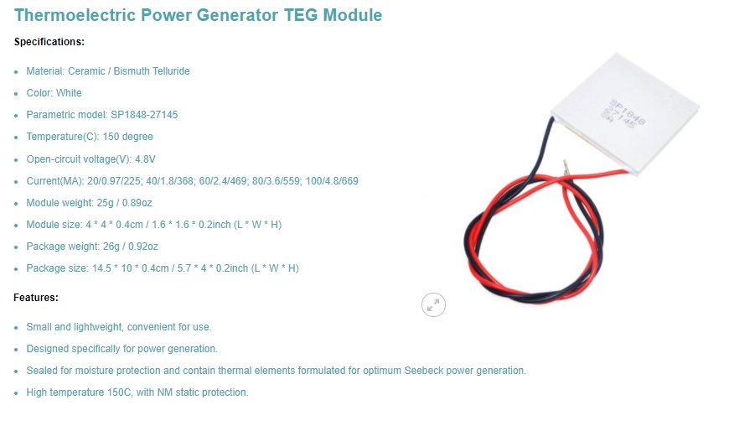

Figure A.1. TEG Model SP1848-27145 specifications

**APPENDIX B**

**DATASHEET OF FURNACE COMPONENTS**

1. **HardieFlex Sheets**



Figure B.1. HardieFlex Sheet properties

1. **Isolite Fire Brick**

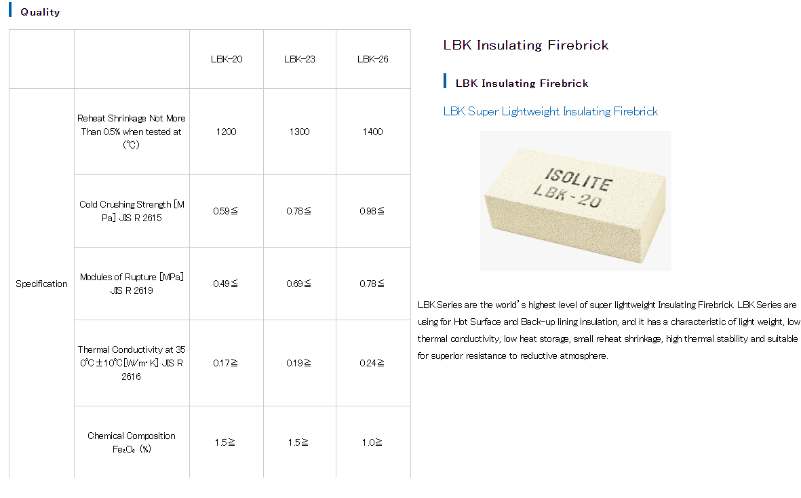

Figure B.2. Isolite Fire Brick LBK-20 properties